Levens CE School

***Loving to Learn, Growing Together, Caring for All***

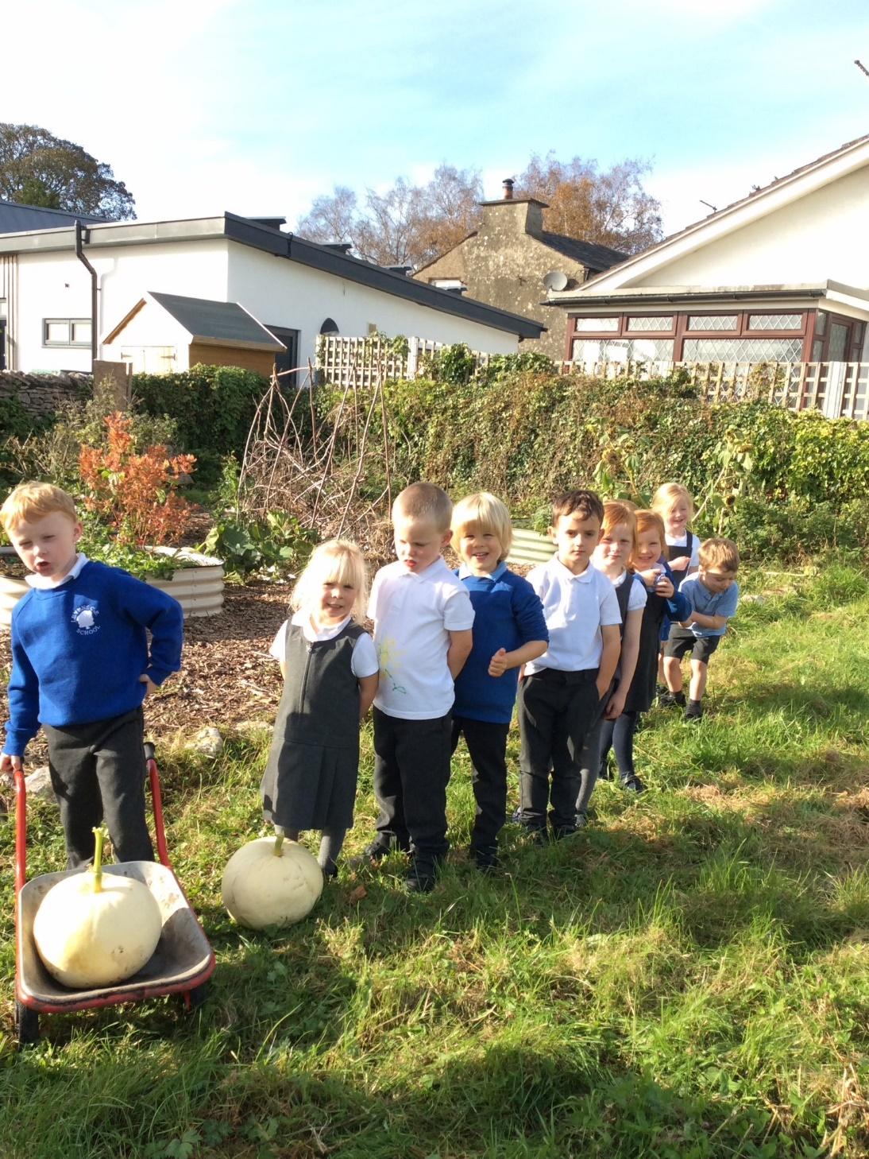

Welcome to Reception

2024

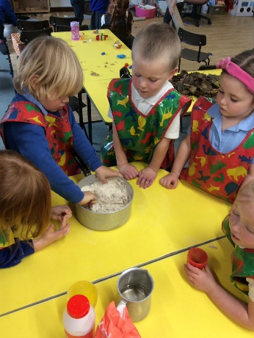

Dear Parents,

On behalf of everyone within our school community, may I welcome you to our school.

Levens CE School is a happy, safe and inspiring place to grow and learn, where we enjoy the learning experiences each new day brings. Everyone is supported and nurtured through our distinctively Christian ethos and shared Christian values.

It is our aim to develop and sustain a life-long love of learning by building for our future in a diverse and ever-changing world.  Rich and wide-ranging experiences enable everyone in school to be creative and develop the personal skills required to be responsible, confident and considerate; taking pride in all that we do.

Starting school is an extremely exciting time for our children and marks a significant milestone in your child's development. Here at Levens, we endeavour to ensure your child’s first experiences of school are positive so that we can lay the foundations for future learning in an environment where your child feels excited about coming to school each day; feels safe; and can build healthy new relationships with adults and their peers.

With a focus on ensuring high standards in reading, writing and maths; we deliver a broad and balanced curriculum relevant to the 21st century. Our Christian ethos pervades every aspect of school; supporting the social, moral, spiritual and cultural development of all pupils.

Relationships are at the heart of the school and our community. Our polite, responsible and enthusiastic pupils are inspired by committed, hardworking staff and school is very well supported by a dedicated governing body. Our parents are another very important part of the team; supporting their child’s learning and the work of school in so many ways.

We are passionate about our school and our pupils; striving to empower their young minds to follow their dreams, be happy and embrace challenge.

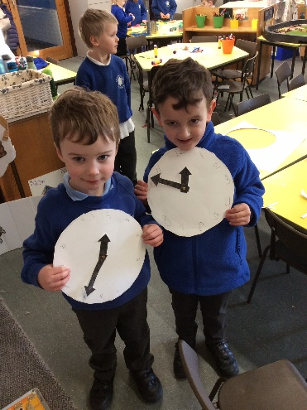This brochure just gives a flavour of what Levens has to offer. For further information why not take a look at our website at [www.levens.cumbria.sch.uk](http://www.levens.cumbria.sch.uk/) or call the school office to arrange a visit. I would welcome the opportunity to take you on a tour of our school.



Jane Farraday

Headteacher

**Starting Reception**

During the summer term prior to your child starting Reception, we like to offer many opportunities for your child to begin their introduction to school. These include our home visit arrangements, classroom sessions and whole school events like our sports day. This will enable your child to meet the staff; be introduced to the school and classroom environment; and begin to learn routines and school expectations.

If your child has attended alternative nursery provision to Levens, staff in school prepare for your child's start by visiting your child in their nursery setting and meeting with your child's key worker. Please note that if your child already attends Levens Nursery, there will no requirement for a home visit and your child will not need to attend additional classroom sessions.

**September 2024**

The Autumn term begins for all children on Wednesday 4th September. The Reception children will start school through a staggered induction period:

Wednesday 4th September – 8.45am – 11.45am

Thursday 5th September – 8.45am – 1pm (staying for lunch)

Friday 6th September – 8.45am – 3.15pm (full day)

**Our Classroom**

The classroom is organised into different areas of learning which are directly linked to the Early Years Foundation Stage. There are opportunities for mark making, reading and writing, practical, hands on maths, creative and malleable areas as well as an open-ended role-play resources. These areas help to develop children’s social and emotional development, communication and language skills and physical development as well as reading, writing and maths. We deliver a balance of teacher led activities which run alongside independent learning opportunities within the classroom.

We also have a beautiful outdoor area where the children have ‘free flow’ access at times during the day. The outdoors plays an important role in developing children’s physical, critical thinking, creative and problem-solving skills.

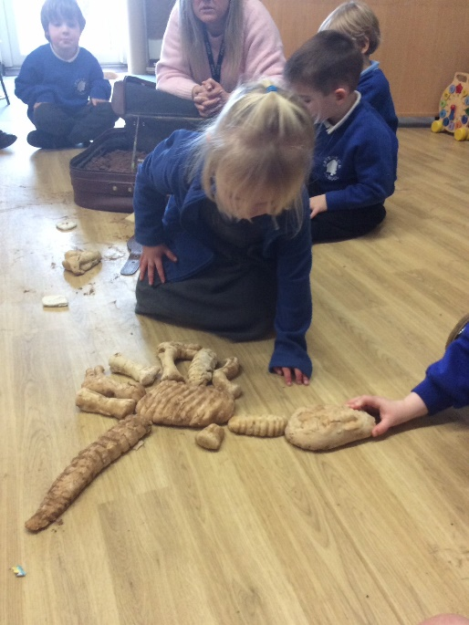

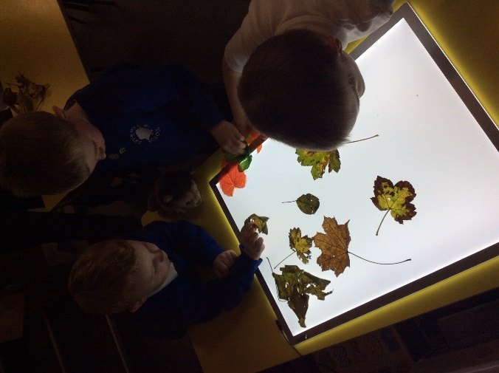

**Learning**

The Early Years Foundation Stage Framework sets the standard for development, learning and care for all children from birth to the end of the Reception year. Activities in the Reception year will be planned within the areas of learning outlined within the Framework and around the interests and needs of individual children to develop their skills and understanding by learning through the playful spirit within our Foundation Stage.

The framework is divided into Prime and Specific areas of learning:

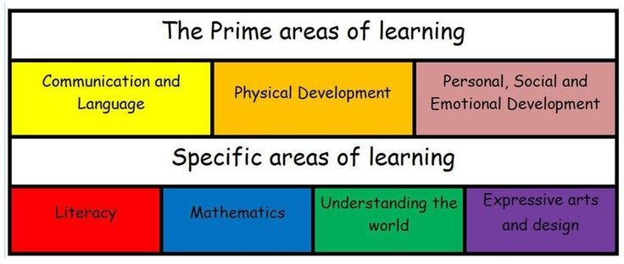

**Monitoring and Reporting our Child's Progress**

We capture the children’s learning through the use of ‘Tapestry’ – an online learning journal and our whole class floorbook. Tapestry is used to document children’s ‘wow’ moments in order to share them with parents and carers and is also used to provide them with a regular overview of learning activities throughout the week.

There are opportunities throughout the year when you will be able to formally meet with the class teacher, see your child's work and discuss their learning and progress. During the summer term, you will receive your child’s End of Year Report. Should you need to discuss your child’s learning and development at any other times in the year, then please let us know; we pride ourselves on being approachable, supportive and helpful.

**Children with Special Education Needs**

At Levens CE School we provide equality for all children, including those identified as having any additional needs. Our setting, our curriculum and the expertise of our staff ensures all children breakdown any barriers to learning in order to access a rich and broad curriculum developing skills and their understanding to make good progress.

Our Ofsted Inspection January 2023 highlighted that ***“Leaders have developed a broad and engaging curriculum that is ambitious for all pupils, including those with SEND”.***

More information about provision for children with SEND can be found on our website or by talking to our SEND lead, Mrs Helen Haslam or the Headteacher, Mrs Jane Farraday.

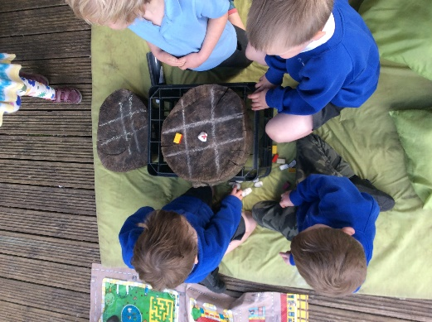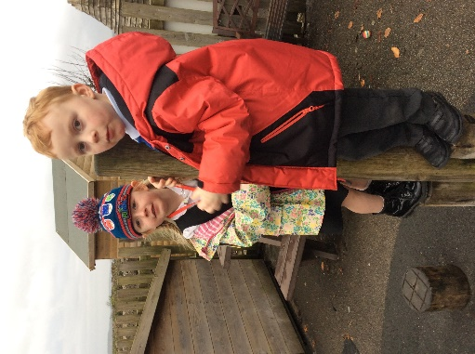

**Arriving in school in the mornings**

Our school day begins at 8.45am and ends at 3.15pm for all pupils. Our gates are open from 8.35am where there will be members of staff from Class One to greet the children on the playground and get them settled into the classroom.

The children in Reception will be encouraged to develop their independence through a range of activities including self-registering and beginning a morning task independently. These routines ensure the children are able to enter a calm and quiet classroom and can settle quickly setting the right tone for learning throughout the rest of the day.

**Reception Fruit and Snack**

All children are offered a piece of fruit or vegetable daily and a drink of milk for a morning snack as part of our healthy eating plan. The fruit is free for all infant children. Milk is free for your child until the term after their 5th birthday; should you wish provision to continue past your child’s 5th birthday, that can be arranged on a payable basis from our suppliers at Cool Milk. Parent need to visit the website termly and arrange payment <https://www.coolmilk.com/parents/>

This time is used for socialising with all of Class One; the children are encouraged to try new foods and learn from each other. The adults join in, modelling behaviour and taking time to chat to the children and reflect on their learning experiences.

**Assemblies and Collective Worship**

Each day, all the children in school engage in worship or assembly time. These special times together as a school or class, enable us to explore our Christian Values, hear Bible Stories, celebrate our achievements and learn more about our world.

On Fridays we have a very special Celebration Assembly when each class will share some of their learning for the week and when we read out names of children who have been mentioned in our Golden Book for something incredible. We like to invite parents to these assemblies on regular occasions through our online website calendar, through newsletters, and via text messages.

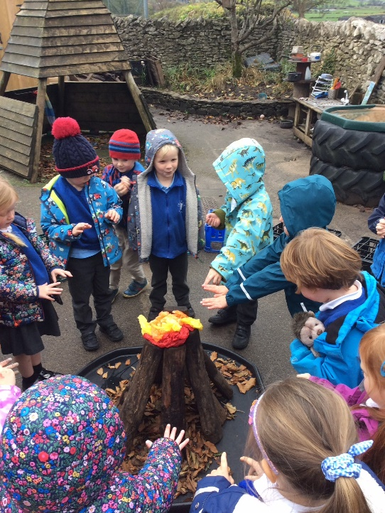

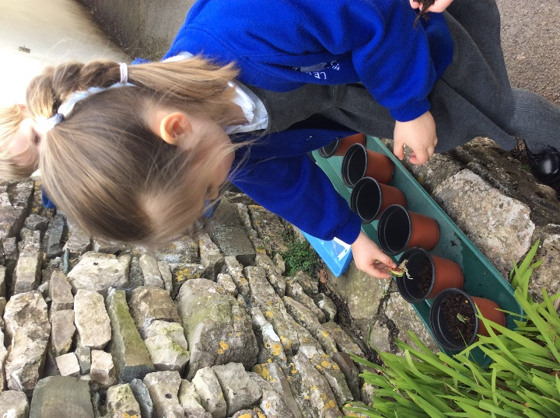

**Lunchtimes**

During this time your child will enjoy a free infant school meal. Daily menus are available to view on the school website. Your child will make their selection each morning with their class teacher, it is useful to discuss the menu for the following day with your child the evening before and make a choice together. The children will enjoy their lunch in our dining hall. Here, staff are always present to ensure the children get enough to eat and drink; learn the routines of our dining hall systems; and enjoy their lunchtime experience. We can readily manage all special dietary requirements and would appreciate early notification so that we can make any necessary preparations or modifications.

**Hometime**

School ends at 3.15pm each day, please collect your child from the playground where a member of the Class One team will meet you. Sometimes a member of staff may wish to talk to you briefly to share something from the day or pass on important information. If someone different is collecting your child please ensure we have been informed, as keeping your child safe is our top priority. The children are taught from day one that they are not permitted to leave the adult in charge to go to parents until they are told to by a member of staff. This is so we are able to ensure we see each child safely delivered to their appropriate adult.

**Safeguarding**

***“Leaders have established a strong safeguarding culture at the school. Staff and governors receive regular safeguarding training. They know how to spot the signs that pupils may be at risk of harm and act promptly to report any worries that they have. Leaders are quick to respond if such concerns are reported”* Ofsted January 2023.**

At our school, the health and safety of all children is of paramount importance. Parents send their children to school each day with the expectation that school provides a secure environment in which their children can flourish.

The Designated Safeguarding Lead is Mrs Farraday, in her absence, the Deputy Designated Safeguarding Lead is Mrs Haslam. Should you have any concerns about the welfare of any children in school, please let us know immediately.

At Levens School we will ensure everything possible is undertaken to safeguard the welfare of all children in our care. If the school has a reason to be concerned that a child may be subject to harm, ill-treatment, neglect or other forms of abuse, staff will take appropriate action.

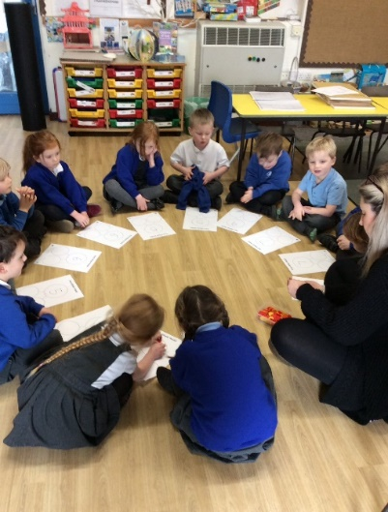

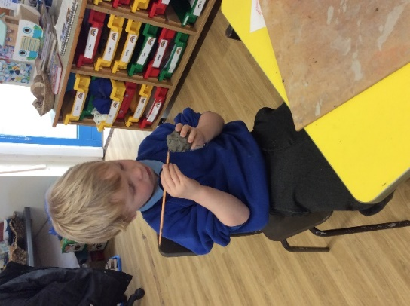

**Your Child's Health**

Sometimes children need prescription medication. In some circumstances, and when the medication timing necessitates that a dose is given during the school day, please speak to Mrs Coker or Mrs Dawson in the office who will be able to help you complete the necessary paperwork that will allow us to administer medicine in school. If your child is asthmatic and needs an inhaler in school during the day, please ensure we are promptly informed as we require certain paperwork completing.

If your child is unwell and unable to attend school, please inform us by either telephoning the office between 8.30am and 9am or emailing a member of the office team at [office@levens.cumbria.sch.uk](mailto:office@levens.cumbria.sch.uk) on the first day of your child’s absence.

During your child’s first year, the School Medical Service will carry out various checks on your child’s growth and development. You will be informed of these checks in advance.

If your child becomes unwell at school or has an accident that may require hospital treatment we would contact you immediately using the contact details you have provided for school. It is a statutory requirement that school has at least two emergency contact details for every pupil in school. We should also be provided with a third contact who does not live in the family home, this is often a grandparent or close family friend.

Children who have received any first aid in school will receive a ‘First Aid’ or occasionally a specific ‘Head Bump’ letter informing parents of details.

**Communication with School**

At Levens CE School, we understand that developing and maintaining strong links with parents is essential to our children’s learning and development throughout their education. Therefore, it is essential that you feel welcome in school and able to talk to us or ask us questions as they arise.

There are several ways to keep in touch with what’s happening in school. Our website includes a ‘blog’ where your child’s experiences in and out of school are posted regularly, alongside photographs. The website also has a calendar providing early notification of forthcoming events. In the pupil’s section of the website, Class One has its own class page with up to date information about curriculum and learning.

Information is also shared via email and the school text alert system. The latter is useful for last minute changes to arrangements and useful reminders. Please ensure you keep us informed of any changes to your contact or personal details as soon as possible. We are only able to have one family mobile number linked to the text system, so please ensure that you provide us with your preferred contact number and that you have the capacity to pass on any relevant messages to those collecting your child that day. Newsletters are distributed at least once every month and are also published on the website. Other letters are also sent home via book bags for specific events or information, sometimes requiring reply slips and payments. These can be sent back into school with your child and placed in the black box positioned next to the children’s water bottles.

Class One also has its very own Instagram page which you can follow by searching levenseyfs. Please note that this page doesn’t publish photographs of pupils. It documents different learning opportunities and activities which parents and carers might like to see.

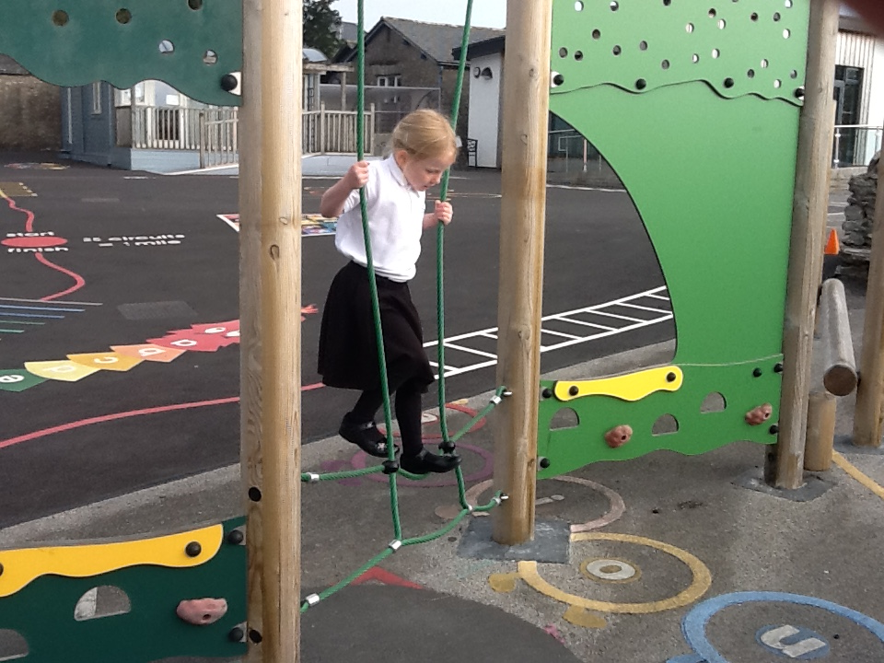

**School Uniform**

Our uniform is a royal blue sweatshirt, fleece or cardigan with a white polo shirt. Both girls and boys may choose to wear grey trousers or a grey skirt, pinafore dress or blue gingham dress. All pupils should wear black shoes and bring an appropriate school coat every day. Please ensure that all items of uniform are clearly named so that they can be reunited with owners easily.

Our school PE kit consists of black shorts; a pale blue t-shirt with the school logo; a pale blue hooded top with the school logo; black PE pumps and trainers. All of these items need to be kept in the essential PE sack, that is available from the suppliers. Please also include a pair of socks. For PE outside the children may wear jogging trousers in colder weather. Your child will also need a book bag. School policy on uniform does not permit the wearing of jewellery or nail polish. Long hair should always be tied up and stud earrings removed on PE days.

All items are obtainable from our suppliers, Coniston Corporate via the link on the school website where a full order form is available. Collated items are then received in school and sent home as soon as possible. Payment is made online and we recommend that you please order in good time.

The table below gives current costs for our most popular items:

|  |  |
| --- | --- |
| Sweatshirt | From £11.10 |
| Cardigan | From £12.35 |
| Fleece jacket | From £16 |
| Book bag | £6.25 |
| School PE kit (t shirt, shorts, bag) | £12.50 (replacement items can be bought separately) |
| School PE hoodie | From £12.50 |

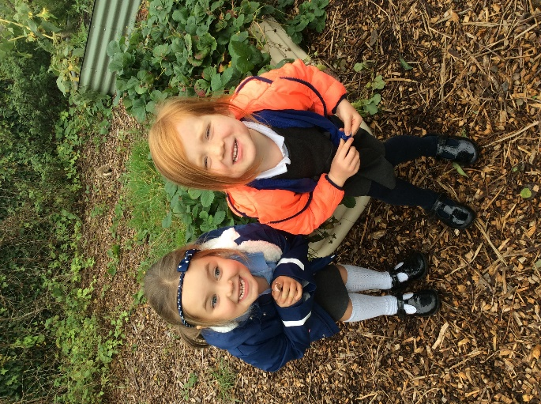

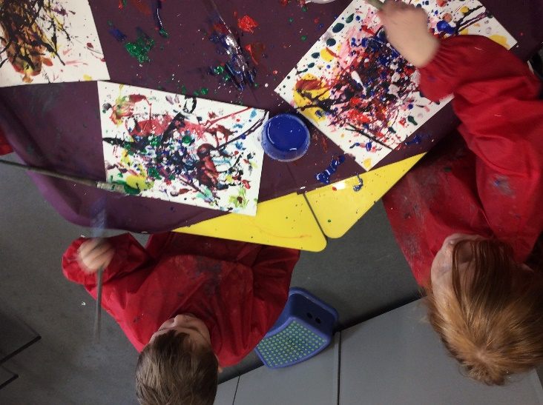

**Meet the team**

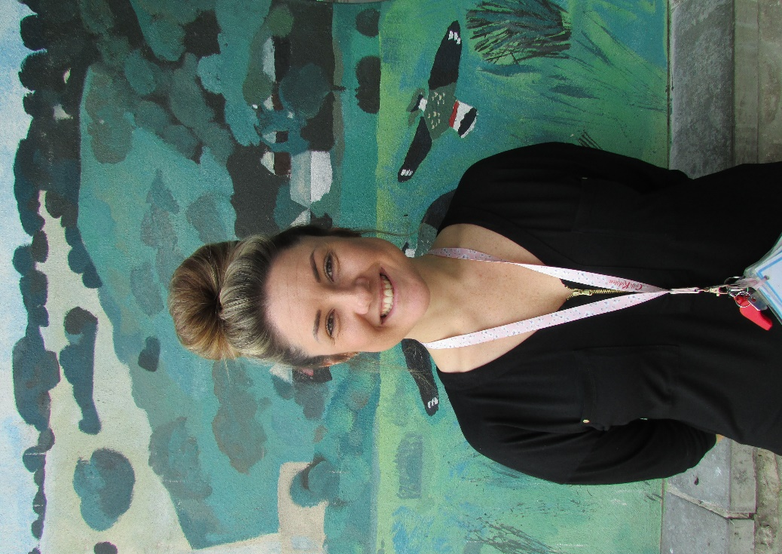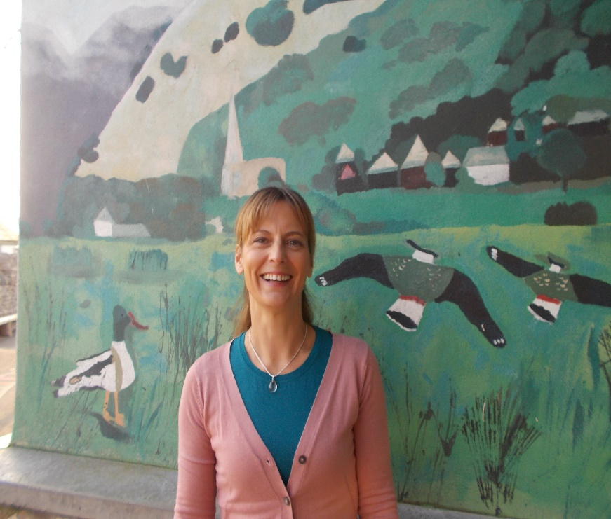

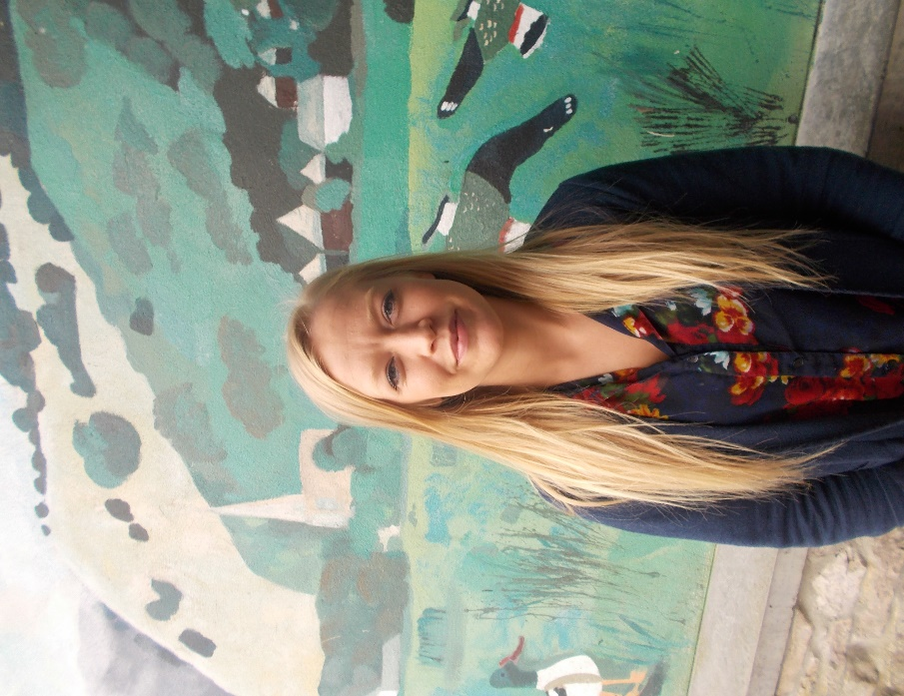

Helen Haslam – EYFS Lauren Butler – Senior Teaching Martine Harwood – Teaching Assistant Teacher, Deputy Headteacher Assistant

and SEND lead



Emily Rockcliffe – Teaching Assistant

Thank you for taking the time to read about our arrangements for your child starting school. Please do not hesitate to contact us if you have any questions or require any further information.

**School Contact Information**

**Address:**

Levens CE School

Church Road

Levens

Kendal

Cumbria

LA8 8PU

**Telephone:** 015395 60694

**Email:** [office@levens.cumbria.sch.uk](mailto:office@levens.cumbria.sch.uk)

**Website:** [www.levens.cumbria.sch.uk](http://www.levens.cumbria.sch.uk/)