

Levens CE School is a happy, safe and inspiring place to grow and learn, where we enjoy the learning experiences each new day brings. Everyone is supported and nurtured through our distinctively Christian ethos and shared Christian values.

It is our aim to develop and sustain a life-long love of learning by building for our future in a diverse and ever-changing world.  Rich and wide-ranging experiences enable everyone in school to be creative and develop the personal skills required to be responsible, confident and considerate; taking pride in all that we do**.**

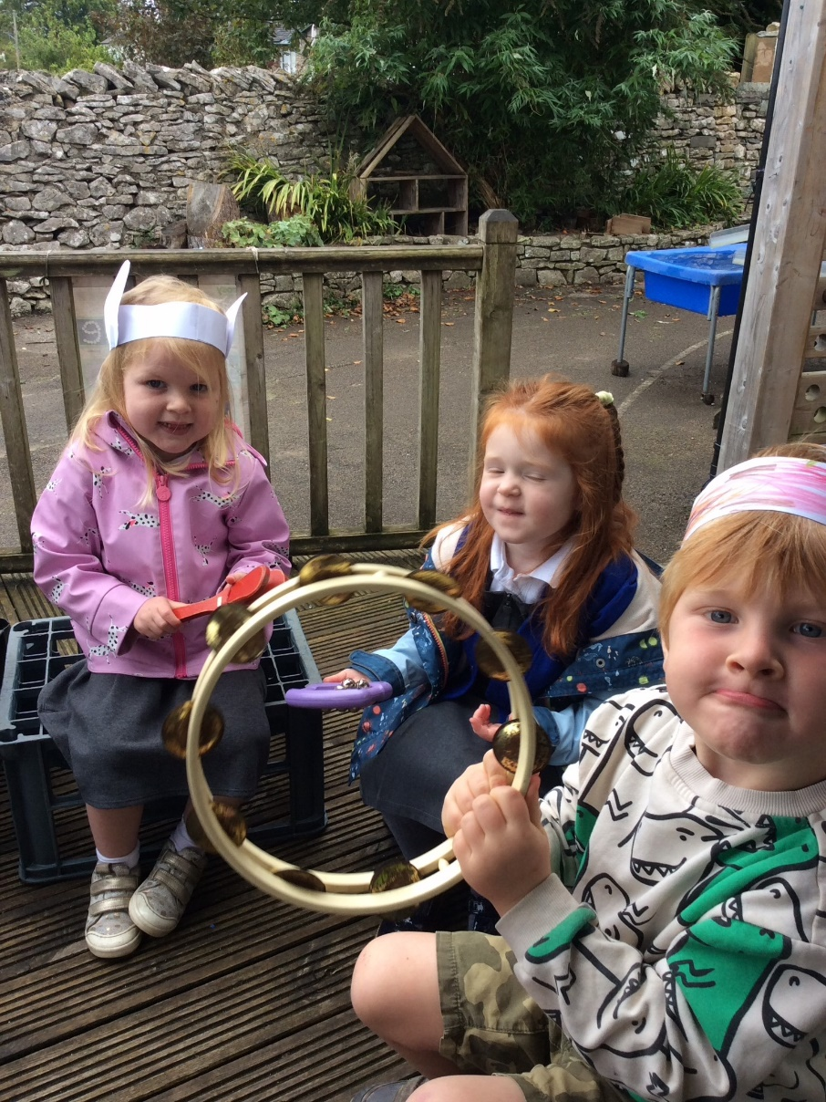

Welcome to Nursery

2024-25

Welcome to Nursery at Levens CE School. Choosing the right nursery for your child is a very important decision. At Levens CE School we provide wonderful learning experiences every day in a safe, secure and happy environment. Our staff team are committed to ensuring the very best education and care for your child.

Our Nursery was opened in September 2016 and is the only provision for pre-school children within a 3 -mile radius. We are pleased to be able to offer up to 30 hours per week, equivalent to 10 sessions. This can be taken in full days, mornings or a mixture of both where there is session capacity. We strongly recommend that children in Nursery attend a minimum of two half sessions per week on different days. Our sessional offer is reviewed annually and reflects the level of demand up to capacity.

Children can join Nursery from the term following their third birthday, either September, January or Easter, (later admissions might be capacity dependent). All children are entitled to 15 hours per week and some families are entitled to up to 30 hours. If you are only entitled to 15 hours, but would like to take more, please speak to us about payable additional sessions. This brochure, along with the information on our website, will provide you with everything you need to know about what our Nursery can offer and how to apply for a place.

If you would like to arrange a visit to school, please do so by contacting the school office.

**Our Nursery**

Our Nursery is part of Levens CE Primary School which caters for children from 3 to 11 years. Pupils are arranged into mixed-age classes; and our Nursery children share Class One with our Reception pupils. Our spacious classroom and outdoor area are well resourced to stimulate and develop rich and varied play.

Parents will need to apply for a Reception place with the local authority for the September after their child turns 4. The local authority will then apply their admissions criteria and coordinate applications for a place in our Reception year.

Home visits with Mrs Haslam and a member of the Nursery team will take place prior to your child starting with us so that we are able to see your child in their own setting and ensure you have all the necessary information before your child starts.

**How much time is my child entitled to?**

All children are entitled to 15 hours Nursery Education per week, but many parents will be entitled to have 30 hours:

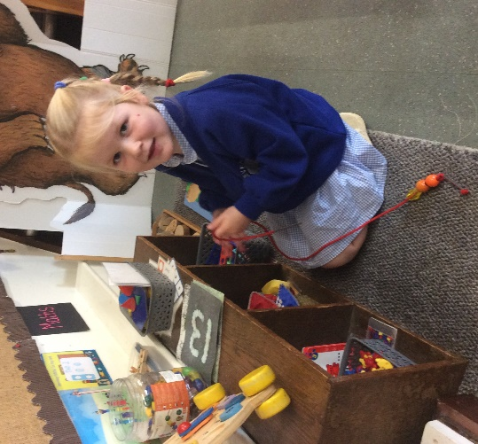

Families who qualify for 30 hours will have:

* 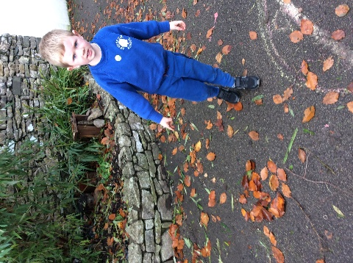A child aged 3 or 4
* Parents who both work more than 16hours a week
* An annual household income of less than £100,000
* Live in England

Each Nursery session is 3 hours

* If you are eligible for 15 hours you can choose 5 free sessions per week.
* If you are eligible for 30 hours you may be able to choose all 10 sessions (dependant on if your child attends another nursery in addition to Levens).
* Information about your entitlement can be found at [www.childcarechoices.gov.uk](http://www.childcarechoices.gov.uk/). There is also a Childcare Calculator at [www.gov.uk/childcare-calculator](http://www.gov.uk/childcare-calculator) where you can see what offers are available to support you and your family.

If you are eligible for a 30-hour free childcare place for 3 and 4 year olds, please provide us with your eligibility code (DERN number), your National Insurance Number and your date of birth, so that we can verify your eligibility.

**Charges for additional sessions above universal 15 hours**

If your child is only entitled to 15 hours, but you would like them to attend more sessions; you can do so but you would be charged for the additional sessions: £18/morning or £36/day. Children staying all day can either bring a packed lunch or have a school meal. Menu choices for school meals can be viewed on our school website and are payable at £3.45 per day.

**Applying for a Nursery Place**

You will need to use our Nursery application form to apply to attend at our Nursery and please ensure you identify your session preferences. The application form is published on our website and can also be found on the back page of this brochure. Please see the website for application windows, as we cannot take applications in advance or reserve places ahead of your application eligibility. It is possible that we might be able to accommodate additional sessions through the year, but this could be session dependant.

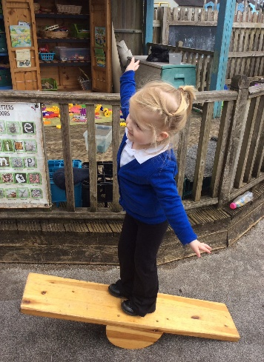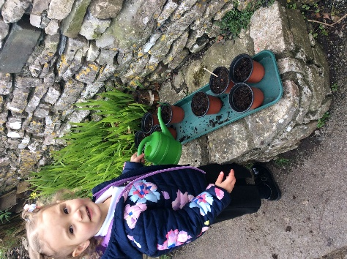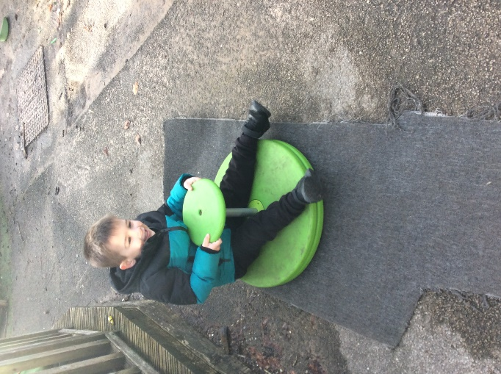

|  |  |
| --- | --- |
| Nursery Start Date | Closing date for applications |
| September | 25th March |
| January | 30th September |
| April | 15th January |

**Available Sessions from September 2024**:

|  |  |
| --- | --- |
| Morning only session  8.45-11.45  (3 hours) | All Day session  8.45-3pm  (6 hours) |

**September 2024**

**Nursery opens on Monday 9th September 2024 at 8.45am**. Doors are open each day from 8.35am. Early Years staff will be on duty to welcome and receive children. If your child is due to start Nursery on this date, we will contact you beforehand in order to arrange a home visit.

**Our Learning Environment**

The classroom is organised into different areas of learning that are directly linked to the Early Years Foundation Stage Framework. Learning opportunities are themed around different age-appropriate books and allow for children’s interests to be followed. There are opportunities for personal, social and emotional development, physical development and promotion of children’s communication and language skills. Children in Nursery are also assigned a Key Person and take part in short, interactive phonics and maths sessions planned by our experienced Nursery staff.

We also have a beautiful outdoor area where the children have ‘free-flow’ access for the majority of the day. The outdoors plays an important role in developing children’s physical, creative and problem-solving skills.

The Framework is divided into Prime and Specific areas of learning:

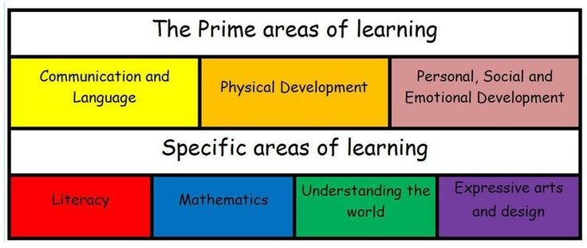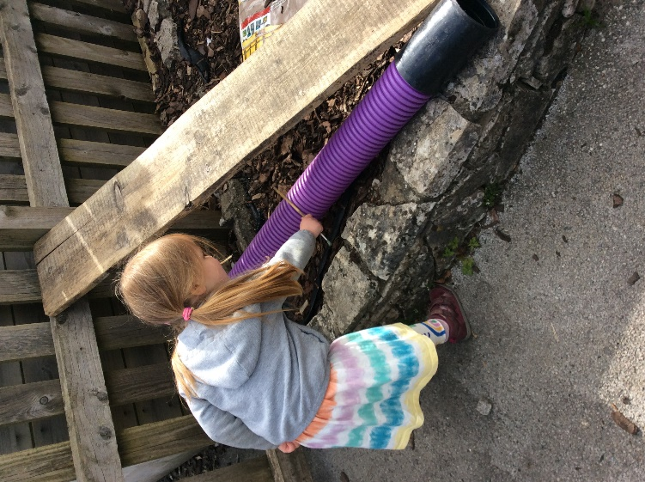

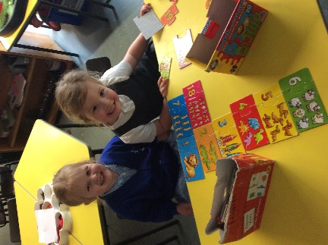

**Monitoring and Reporting our Child's Progress**

The children’s learning is captured in two ways within our Foundation Stage:

* An online learning journey - 'Tapestry' which can be viewed and added to by both staff and parents.
* A whole class learning journey scrapbook which displays and details adult-led and child-initiated work and activities.

There are opportunities throughout the year when you will be able to formally meet with your child’s Key Person to discuss their learning and progress. If your child is due to move to Reception then you will receive your child’s End of Year Report during the summer term.

Should you need to discuss your child’s learning and development at any other times in the year, then please let us know; we pride ourselves on being approachable, supportive and helpful.

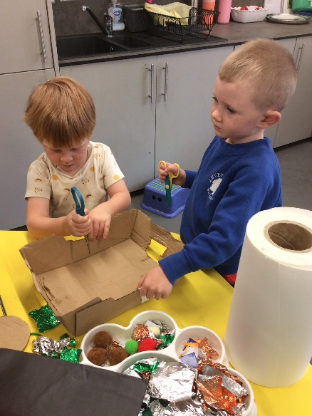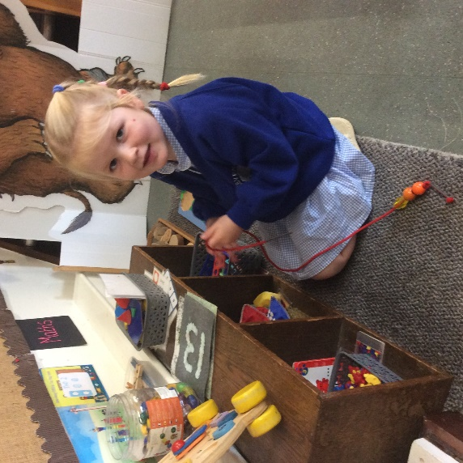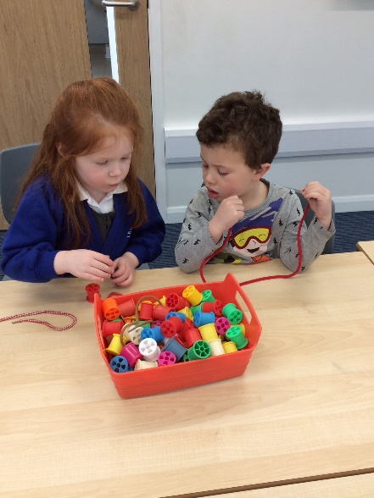

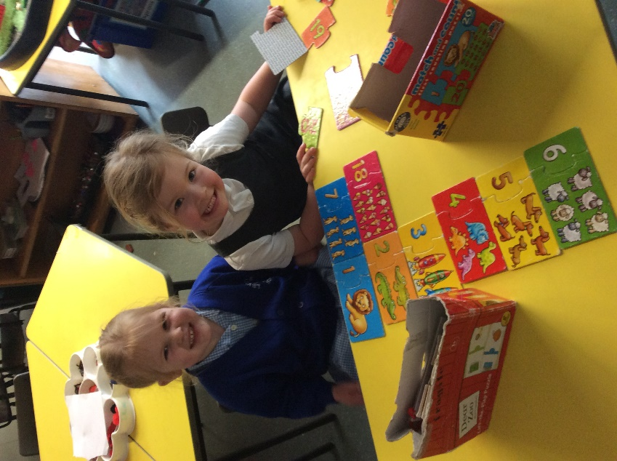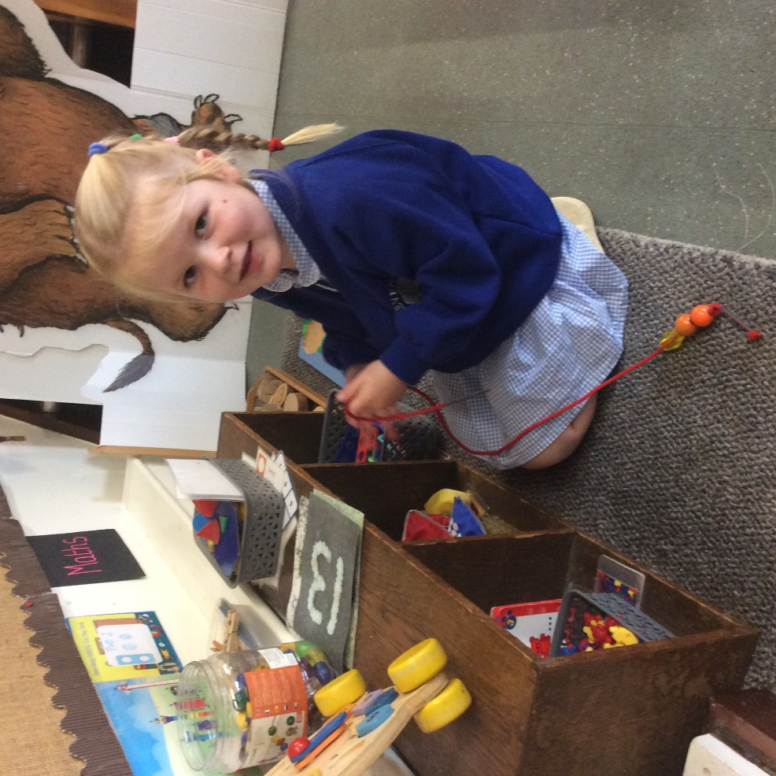

**Children with Special Education Needs**

At Levens CE School we provide equality for all children, including those identified as having any additional needs. Our setting, our curriculum and the expertise of our staff ensures all pupils are able to breakdown any barriers to learning in order to access a rich and broad curriculum developing skills and their understanding to make good progress.

***‘Leaders are quick to spot the additional needs of pupils with SEND, including in the early years.’ Ofsted January 2023***

More information about provision for children with SEND can be found on our website or by talking to our SEND lead, Mrs Helen Haslam or the Headteacher, Mrs Jane Farraday.

**What will your child need?**

* Our uniform is optional for Nursery children, though most of our children do choose to wear it.
* Easily managed shoes – Velcro is best, no laces please!
* Three sets of spare clothing (this does not have to be uniform) including underwear, socks and spare footwear.
* Weather dependent clothing – sun hats in the summer and hats, scarves, a warm coat and gloves in the winter.
* A puddle/splash suit and wellies (children will be unable to partake in certain activities without these).
* A water bottle.
* A small rucksack containing their spare clothing.

**Please ensure everything is named**

The table below gives current costs for our most popular items:-

|  |  |
| --- | --- |
| Sweatshirt | £11.10 |
| Cardigan | £12.35 |
| Fleece Jacket | £16.00 |
| Book Bag | £6.25 |

All items are obtainable from our suppliers, Coniston Corporate via the link on the school website where a full order form is available. Collated items are then received in school and sent home as soon as possible. Payment is made online and we recommend that you please order in good time.

As your child is in Nursery, we do not expect them to wear full and complete school uniform, although most of our children do choose to wear a school jumper, fleece jacket or cardigan.

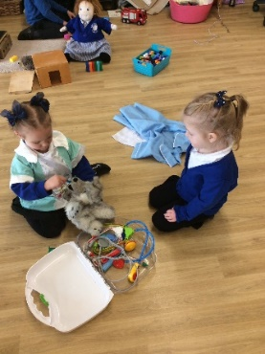We regularly hold pre-loved uniform sales where good quality items can be picked up for a fraction of the price.

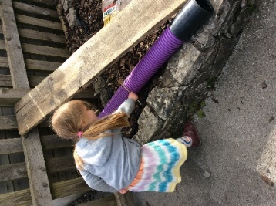

**Arriving in school in the mornings**

All children enter school through the Class One gate situated to the left of School’s main entrance. Each morning the children in Nursery will be encouraged to develop their independence through a range of activities including: choosing their lunch, self-registering and beginning a morning activity alongside their peers. These routines ensure the children are able to enter a calm and quiet classroom and are able to settle quickly which sets the right tone for learning throughout the rest of the day.

**Fruit and Milk**

All children are offered a piece of fruit or vegetable daily and a cup of milk for snack as part of our healthy eating plan. The fruit is free for all infant children. Milk is free for your child until their 5th birthday.

This time is used for socialising with all of Class One; the children are encouraged to try new foods and learn from each other. The adults join in, modelling behaviour and taking time to chat to the children and reflect on their learning experiences.

**Lunchtime Provision**

The lunchtime session begins at 11.45am, and the lunchtime break is for one hour. During this time your child will be able to enjoy a cooked school meal or bring a packed lunch. Daily menus are available to view on the school website and meals are priced at £3.45. The Nursery children eat with Reception in our dining hall.

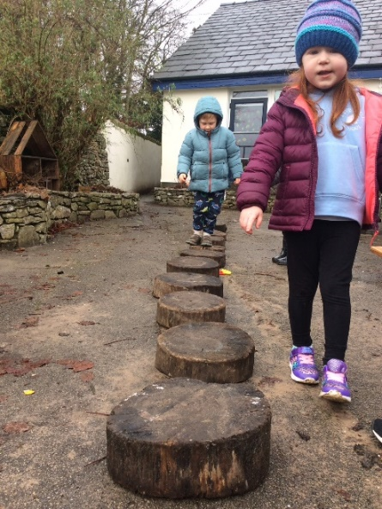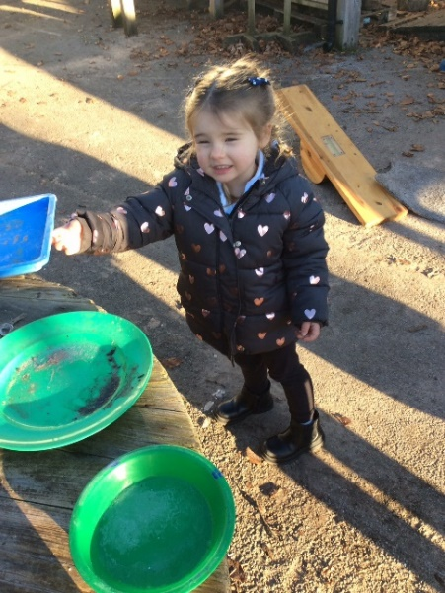

**Potty/Toilet Training**

It is anticipated that most children in Nursery will be able to use the toilet, however if this is not the case please discuss your child’s needs with us prior to their starting date.

**Safeguarding**

At our school, the health and safety of all children is of paramount importance. Parents send their children to school each day with the expectation that school provides a secure environment in which their children can flourish.

***‘Leaders have established a strong safeguarding culture at the school. Staff and governors receive regular safeguarding training. They know how to spot the signs that pupils may be at risk of harm and act promptly to report any worries that they have. Leaders are quick to respond if such concerns are reported.’* Ofsted January 2023**

The Designated Teacher in Charge of Safeguarding is Mrs Farraday. In her absence, the Deputy Designated Safeguarding Lead is Mrs Haslam. Should you have any concerns about the welfare of any children in school, please let us know immediately.

At Levens CE School we will ensure everything possible is undertaken to safeguard the welfare of all children in our care. If the school has a reason to be concerned that a child may be subject to harm, ill-treatment, neglect or other forms of abuse, staff will take appropriate action.

**Your Child's Health**

Sometimes children need to take prescription medication during school hours. If this is the case, please speak to Mrs Coker or Mrs Dawson in the office who will be able to help you complete the necessary paperwork for us to administer medicine in school. If your child is asthmatic and needs an inhaler in school during the day, please ensure we are promptly informed as we require appropriately completed paperwork.

If your child is unwell and unable to attend school, please inform us by emailing [office@levens.cumbria.sch.uk](mailto:office@levens.cumbria.sch.uk) (or phoning between 08.30 and 09.00 if email is not possible), on the first day of your child’s absence. During your child’s first year at school the Schools’ Medical service will carry out various checks on your child’s growth and development. You will be informed of these checks in advance.

If your child becomes unwell at school or has an accident that may require hospital treatment we would contact you immediately using the contact details you have provided for school. Children who have received any first aid in school will receive a ‘First Aid’ or ‘Head Bump’ letter informing parents of details.

Please ensure that you provide us with all contact information for those with parental responsibility for your child as well as one other person, who does not live at the home address, but who can be contacted in the case of emergencies.

**Communication with School**

At Levens CE School, we understand that developing and maintaining strong links with parents is essential to our children’s learning and development throughout their education. Therefore, it is essential that you feel welcome in school and able to talk to us or ask us questions as they arise.

There are several ways to keep in touch with what’s happening in school. Our website includes a ‘blog’ where your child’s experiences in and out of school are posted regularly, alongside photographs. The website also has a calendar providing early notification of forthcoming events. In the pupils’ section of the website, Class One has its own page with up to date information about curriculum and learning.

Information is also shared via the school emailing system and also via a text alert system, (the latter sent to the first named contact only). The text facility is useful for last minute changes to arrangements and useful reminders. Please ensure you keep us informed of any changes to your contact details as soon as possible. Newsletters are distributed at least once every month and are also published on the website. Other letters are forwarded by email and some are also sent home via book bags for specific events or information, sometimes requiring reply slips and payments. These can be sent back into school with your child and placed in the black box positioned in the classroom. All payments need to be made by cheque, made payable to Westmorland and Furness Council, or by cash.

Class One also has its very own Instagram page which you can follow by searching levenseyfsy1. Please note that this page does not publish photographs of pupils. It documents different learning opportunities and activities which parents and carers might like to see.

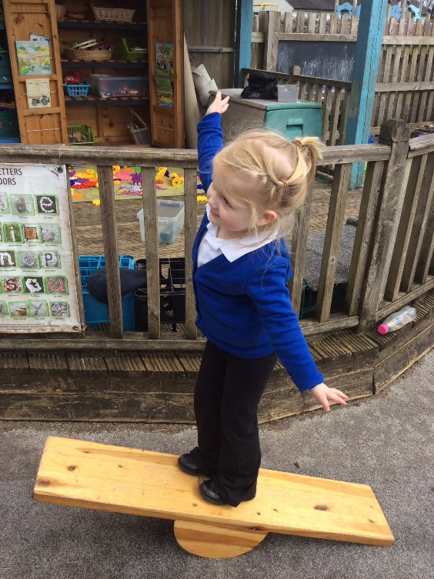

Thank you for taking the time to read about our arrangements for your child starting Nursery. Please do not hesitate to contact us if you have any questions or require any further information.

**Contact Information**

**Address:**

Levens CE School

Church Road

Levens

Kendal

Cumbria

LA8 8PU

**Telephone:** 015395 60694

**Email:** [office@levens.cumbria.sch.uk](mailto:office@levens.cumbria.sch.uk)

**Website:** [www.levens.cumbria.sch.uk](http://www.levens.cumbria.sch.uk/)

**Meet the Class 1 team**

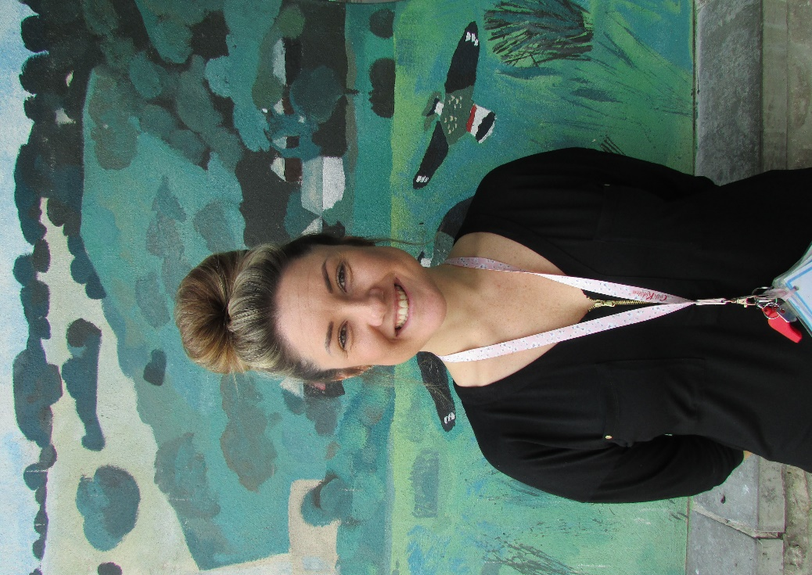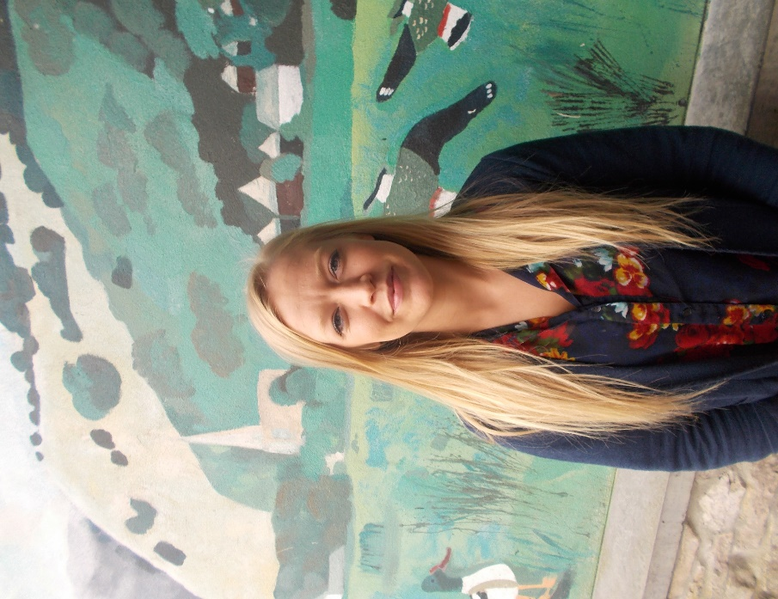

Helen Haslam – EYFS Lauren Butler – Senior Teaching Assistant

Class Teacher, Deputy Headteacher&

SEND Lead

|  |  |  |
| --- | --- | --- |
|  |  |  |
|  | C:\Users\Hilary\AppData\Local\Temp\Temp1_archive (1).zip\Mrs Martine Harewood.JPG |  |
| https://www.levens.cumbria.sch.uk/wp-content/uploads/2024/02/Staff-Profile-ER-150x150.png |  |  |
| Emily Rockcliffe – Teaching Assistant | Martine Harwood - Teaching Assistant |  |
|  |  |  |
|  |  |  |